

TOM
Outline Architecture

Finance Package F012 – OFi Vendor Interface to ORMS Supplier

Version: | 1.2.9
Author: | Thomas Harper
Date: | 13.03.2007

Version: | 1.2.9
Author: | Thomas Harper
Date: | 13.03.2007
Project BEN Code: | W60416
Circulation Restrictions: | Tesco Internal Only
Status: | Final

Document Information

Change Record

Author | Date | Version | Change Reference, description
Thomas Harper | 23/01/2007 | 1.0.0 | Draft
Thomas Harper | 30/01/2007 | 1.1.0 | Incorporated OFi flexfield changes. Highlighted mapping assumptions.
Thomas Harper | 31/01/2007 | 1.2.0 | Finalised assumptions
Thomas Harper | 01/02/2007 | 1.2.1 | Added missing LAST_NAME field
Thomas Harper | 12/02/2007 | 1.2.2 | Changed input file to pipeline delimited
Thomas Harper | 12/02/2007 | 1.2.3-4 | PrePaid Supplier and Costing flags added
Thomas Harper | 13/02/2007 | 1.2.5 | PrePaid Supplier and Costing changes struck out
Thomas Harper | 27/02/2007 | 1.2.6 | End of record indicator aligned to .TXT file unix output (CRLF)
Thomas Harper | 06/03/2007 | 1.2.7 | Common Forms references added  IDS Supplier inserting clarified
Thomas Harper | 07/03/2007 | 1.2.8 | VENDOR_SITE_CODE will be concatenated to VENDOR_NAME  All SITE_TYPES will be 04 for USA  EMAIL will be included in the extract
Thomas Harper | 13/03/2007 | 1.2.9 | Outstanding issues added before sign off

Reviewers

Name | Date | Version | Role
Sidd Sarangi |  |  | Business Analyst
Nigel Glenn |  |  | Enterprise Architect
Nathan Smith |  |  | Enterprise Architect
David Onyett |  |  | Project Leader
Jonathan Brimley |  |  | IBM Consultant, USA

Distribution

Name | Role
Nigel Glenn | Enterprise Architect
Nathan Smith | Enterprise Architect
Ann Merritt | Enterprise Architect
Duncan Wellberry | TOM Programme Manager
Rae Topp | TOM Integration Project Manager
David Onyett | TOM Integration Project Manager
David Briggs | Group IT Distribution and Head Office Systems Portfolio Manager
Jonathan Brimley | IBM Consultant, USA
Sidd Sarangi | Business Analyst
David Briggs | HO Portfolio Manager

References
All documents are held in Sharepoint.
Document | Where held | Version & date
Solutions Architecture | Not Available
Business Requirements Document | docshare
Project Technical Systems Design | Not Available
Funding Project Plan
Integration Context Diagram.vsd | TOM Vendors to ORMS Supplier Integration Context Dgm v1.1.vsd  page: VENDORS via Biztalk
IS Order Spec - Transformation of Oracle Finance Supplier to ORMS exploded Supplier xml | TOM Integration Finance docshare

Sign-Off
By signing this form, I understand and agree with the contents of this document.

Business Owner/Customer | Nigel Glenn
Role | Enterprise Architect
Signature | Nigel Glenn
Date | 13/03/2007

Table of Contents
Table of Contents v
1. Introduction 7
1.1. Purpose 7
1.2. Background 7
1.3. Scope 9
1.3.1. In Scope 9
1.3.2. Out of Scope 9
2. TOM Project high-level requirements 9
3. Information Architecture High Level Design 9
3.1. The scope of this Integration Design covers 9
3.2. Interfaces 10
3.3. Context Architecture 11
4. Oracle Extraction Requirements (Application Project) 12
4.1. Switch Off BPEL SendVendorToOracle Retail processing (Application Project) 12
4.2. Extract File (Application Project) 12
4.3. File Transmission (Application Project) 12
4.4. Post Transmission Cleanup Script (Application Project) 12
5. Information Services Requirements 12
5.1. Interfaces (TOM Integration Project) 13
5.1.1. 13
5.2. Data Requirements 13
6. Physical Deployment 13
7. Benefits and concerns 13
7.1. Benefits/key features 13
7.2. Concerns/risks 13
8. Deliverables and high-level Estimate 14
Appendix A Data Definitions and Mappings 17
A.1 OFi Extracted Record Fields 17
A.2 The Extract Script 18
A.3 Sample extract file 23
A.4 End to End Mapping 23
8.1. Mapping – Flat File to Common Form 27
8.2. Mapping – Common Form to RIB 27
8.3. Writing to the IDS 27
8.4. Stored Procedures 27
8.5. Common Form Schemas 27
A.5 OFi Source Data 28
A.6 RIB RMS message format 40

Introduction

The Oracle Vendor interface isn’t fit for Tesco use. The BPEL changes needed to make it fit for purpose won’t be ready in time for go live. We will develop our own interim solution with the following caveats and assumptions

HIGH LEVEL ASSUMPTIONS

- IN the ABSENCE of a SOLUTION ARCHITECTURE DOCUMENT:-
  - A flat file of Vendors + Sites will be extracted from Ofi
  - Extracts from Oracle Financials will be updated records only (i.e first time through we get the lot, afterwards only changes)
  - Extraction is repeated hourly due to Supplier suspension requirements

- IN the ABSENCE of a PROJECT TECHNICAL DESIGN:-
  - This document will provide sufficient information for the Interface Specification to be written.
  - It is assumed tha the Information in Oracle Technical manuals and a physically implemented database gives sufficient information to carry out the integration
  - Values held in certain fields will map directly between Ofi and ORMS applications e.g. Country.

- Outstanding Issues
  - At the time of sign-off the following issues remain to be resolved
    - Finance SIPOCS 3.5 are still awaited.
    - OFi use of Country versus ORMS use of ISO Country Code.
This will probably be resolved using a reverse lookup translation table in the Integration Layer. In the meantime OFi Vendor setup will have to use the 2 digit ISO Country code when setting up addresses.
    - OFi Payment Terms verses ORMS Payment Terms. Similar issues to country are expected around this field.

Purpose
This document describes the TOM Programme’s high level requirements for a Vendor to Supplier interface between Oracle Financials (OFi) and Oracle Retail Merchandise System (ORMS)
From these requirements the document proposes an Integration design and lists key involvements. This will provide information to the application project, the Integration development and the TOM programme plan.

Background
The TOM Project is to implement repeatable Group based solutions mainly centred on Oracle Applications. Integration is required between these packages where the integration is either not yet completed by Oracle or the Oracle integration does not meet Tesco requirements.
The Integration deliverables for Oracle Finance (OFi) replace the Oracle provided integration between OFi and ORMS and OFi and ReIM where the manufacturers solution is not fit for Tesco purpose.
ORMS Supplier setup will be controlled from OFi by sending Vendor information to ORMS.
The OFi Vendor table holds the Vendor as a Master Record with child Vendor Site Addresses. If transferred directly to ORMS using the “out of the box” integration only the first address would ever be referenced as the Supplier. To overcome this difference it is necessary to “explode” the Financials Record such that there will be a main Supplier Record in ORMS corresponding to each Vendor Supplier Address as held in the Supplier_Site data flex field (DFF) in Financials.

The Vendor Address Supplier_Site DFF (ATTRIBUTE10) value will be used as the ORMS Supplier Key . The Vendor Id is held in SEGMENT1.

Master Vendor
Vendor Site 1
Vendor Site 2
Vendor Site 3
ORMS
FINANCIALS
Supplier 1
Supplier 2
Supplier 3
PO_VENDOR_SITES_ALL
PO_VENDORS
SUP

Note that the change means that the 5 digit PO_VENDORS_SITES_ALL.Attribute10 in Financials becomes the 5 digit SUP.SUPPLIER in ORMS.

For PO_vendors table, the "supplier number" data is stored in the Segment1 field. For the PO_vendors_sites_all table, the "vendor site dff " is Attribute10.

The Vendor and Vendor sites will also have a mandatory flex field ‘Costing Date’ with options ‘Order Date’ & ‘Delivery Date’. This information will be defaulted to Vendor sites from the Vendor level but can be changed at site level. This data will be interfaced to the ORMS supplier.
[assumption – this is yet to be confirmed and detailed]
ORWMS
Store Systems
Store Systems
8
Storeline
10
ORWMS
5
GFO
10
RMS
30
OFI
Supplier Id Size
System
Supplier Id
Raw Sales
Supplier Id,
Receipts
Master
Supplier
Supplier
Supplier 1
Supplier
Supplier 3
Supplier
Supplier 2
Supplier 1
Supplier 2
Supplier 3
Trait
Master

Scope

In Scope

Integration of Oracle Vendors to ORMS Suppliers
Persisting of Supplier data in the Integration Data Store (IDS) in the Integration Layer

Out of Scope

All Other OFi to ORMS and ReIM Interfaces

TOM Project high-level requirements

Information Architecture High Level Design

The scope of this Integration Design covers

- Extract Vendor and Vendor Adress data from OFI using a script to create a flat file
- Transmit extracted file from Oracle Financials to Biztalk using XCOM[Assumption] or will be written to a CIFS share
- File Receive into Biztalk using RTI Adapter.
- Debatch Flat file
- Transform Flat file to the relevant Common Forms
- Create copy of Common Forms
- Transform Common format to RIB format Supplier XML message
- Use Sysrepublic Real Time Integrator Database Command Script adapter to publish Supplier messages to the Supplier JMS Topic on the Retek Integration Bus (RIB)
- Write the copies of the Common Format messages to a file share for IDS Import via SSIS

Interfaces
There is 1 interface between Oracle Financials and ORMS, as shown on the next page. Reference:
Context Diagram: Supplier to ORMS from Oracle Financials
Page Name: Vendor via Biztalk

Context Architecture
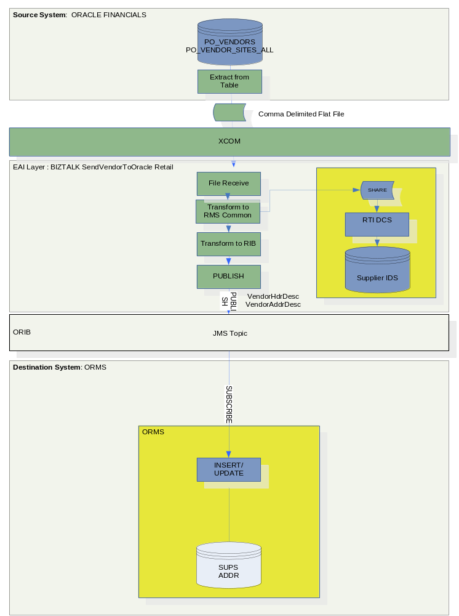
Interface 1: Oracle Financials Supplier to ORMS Supplier
Oracle Financials sends an extracted Supplier flat file to a Biztalk File Receive location. Biztalk converts the file to a Common Form then to RIB format and loads it to ORMS via the RIB. A SQL Supplier database in the Integration Layer will also be loaded using the Common Form during this process.

Oracle Extraction Requirements (Application Project)
The Extraction Code will be specified and coded by the Application Project ].

Switch Off BPEL SendVendorToOracle Retail processing (Application Project)

Extract File (Application Project)
Only certain supplier sites are needed for ORMS. Only records with the Flex Field ORMS_FLAG set to “Y” will be extracted.
The Vendor (PO_VENDOR table) and Vendor Sites (PO_Vendor_Sites_All) records will be extracted using an inner join to create a combined record for each Vendor Site together with contact details from Vendor Contacts (PO_Vendor_Contacts).
The combined records will hold information from the appropriate fields from the Vendor master and from each child Vendor Site and Associated Contact information.
For PO_vendors table, the "supplier number" data is stored in the Segment1 field. For the PO_vendors_sites_all table, the "vendor site dff " is Attribute10.”
The extracted records will therefore use the data in Segment1 to provide the number for the Vendor id and will use Attribute10 to provide the number for the Vendor Site Id
The extracted records will constitute a flat file.
Fields will be pileline ‘|’ delimited.
CRLF will delimit end of record.
The extraction will be scheduled for an hourly [Assumption] transmission. (If Vendors are suspended we will want the information propogated fairly rapidly).
The extract will comprise all records changed since the last extract.

File Transmission (Application Project)
The file will be extracted to a CIFS based share.
An hourly [Assumption] schedule will be set up to run the extraction.

Information Services Requirements
The Integration Interface Specification, the Mapping Spreadsheet and the coding of the Interface will be carried out by the Tom Integration Project.

Interfaces (TOM Integration Project)
The interface will be implemented on the BizTalk 2006 platform.
The following interface makes up the TOM Integration Project interface package:

A Biztalk Orchestration Receives the extracted flat file into a Pipeline where it is debatched.
The Orchestration transforms each flat file record into a Supplier, Address and Activity Common form XML message.
A parallel process is created to make copies of the Common Forms and to pass them to the RTI Database Command Script adapater which will write the records to the IDS.
(Note: The Supplier IDS is for use by other systems that need supplier information).
The Common Forms are Transformed into a RIB format message
The message is Published onto the RIB by the Sysrepublic RTI JMS Adapter.
An MSI for this Interface will be configured and generated for deployment purposes together with a Release Note.

Data Requirements
See the Appendix for data requirements.

Physical Deployment
The interface will be deployed into a standard Tesco EAI BizTalk 2006 environment using an MSI process.

A Release Note will document the installation process.

Benefits and concerns

Benefits/key features
The new interface will be implemented on the strategic BizTalk 2006 platform, replacing the Oracle provided Integration with an Integration that meets Tesco requirements.

Concerns/risks
At the time of writing

- There is no Solutions Architecture feeding into this design
- There is no Project Technical Design feeding into this design
- The BizTalk 2006 environment is new for Tesco, and the design / development / operational processes are not as mature as for the BizTalk 2002 environment

Deliverables and high-level Estimate
The column marked Gen/Spec shows whether the build is generic (G), e.g. reusable by other projects, or specific (S) to this project.

Activity | Interface | Required by for Integration Test | Complexity | Dev/UT Estimate (Days) | Gen/Spec | Comments
1 | Program Specification for theOracle Extract  [Application Project] | 28/03/2007 | L | 1 | S | 1. Must include layout for extracted records  2. Must specify that a record is output for each child site address. (This can be done using an inner JOIN for the site address in the SELECT statement). Only one set of contact details will be forwarded to ORMS. Where this is held in the Vendor_Contacts table only the first contact will be used.  3. As we are selecting changes the select statement should include something like:- “where table VENDORS. LAST_UPDATE_DATE > sysdate-1 (for updates today) or VENDORS. LAST_UPDATE_DATE > date/time of start of last extract run.”  4. Only select where flex field ORMS_FLAG for orms is set to “YES”.  For PO_vendors table, the "supplier number" data is stored in the Segment1 field. For the PO_vendors_sites_all table, the "vendor site dff " is Attribute10.
2 | Oracle Extract Script  [Application Project] | 28/03/2007 | L | 1 | S | Extract Vendors and Vendor Sites Output a combined record for every site as a pileline ‘|’ delimited flat file.
3 | Schedule Extracts  [Application Project] | 28/03/2007 | L | 0.5 | S | Configure the scheduler to run the extract at specified time intervals
4 | Switch off BPEL process SendVendorToOracle Retail  [Application Project] | 28/03/2007 | L | 0.5 | S | We don’t want to send Vendor updates via the manufacturer’s provided interface
5 | Mapping Spreadsheet  [IS} | 28/03/2007 | M | 1 | S | Specify transformation rules
6 | Interface Specification [IS} |  | M | 2 | S | Specify the Interface
7 | Extend Common Form to Support this Interface’s requirements [IS} | 28/03/2007 | M | 2 | G | Extend Supplier Common Form
8 | Flat File Schema [IS} | 28/03/2007 | M | 1 | S | Specify the schema for the incoming flat file
9 | Maps [IS} | 28/03/2007 | M | 1 | S | Create Maps for Flat File to Common and Common to RIB
10 | Biztalk Interface  Financials Vendor and Sites to ORMS Supplier and to IDS Supplier [IS} | 28/03/2007 | H | 7 | G | Receives file  Maps Supplier Vendor+Site records into separate Suppliers for ORMS (output is to Common RMS Supplier Message Schema).  Set up parallel flow. On first output the record to a share for IDS Import Processing. On the second, pass the common msg to a transform to RIB process.  Pass the message to the RTI Adapter to publish to the RIB.  Platform BizTalk 2006
11 | Interface MSI [IS} | 28/03/2007 | M | 3 | S | Build the Deployment MSI for the Biztalk Assemblies
12 | Release Note [IS} | 28/03/2007 | M | 2 | S | Specifies the Release Processes
- Data Definitions and Mappings
These data requirements are derived from :-
Oracle Accounts Payable Technical Reference manual
ORMS Data Dictionary manual
Oracle Retail RMS-Oracle Financials Implementation Guide manual
RIB Mapping Report Release 12.0.0 manual
ORMS Data Dictionary manual
It should be noted that there is no Project Technical Reference Document for this interface.
  - OFi Extracted Record Fields
TABLE | FIELD NAME | TYPE
PO_VENDORS | VENDOR_ID (from table key) | 6 NUMBER
PO_VENDORS | VENDOR NUMBER VENDOR_ID (from SEGMENT1 field) | 6 NUMBER
PO_VENDOR_SITES_ALL | VENDOR_SITE_ID (from Table key) | 5 NUMBER
PO_VENDOR_SITES_ALL | VENDOR_SITE_ID (from ATTRIBUTE10 field)) | 5 NUMBER
PO_VENDORS PO_VENDOR_SITES_ALL | VENDOR_NAME + “ “ +  VENDOR_SITE_CODE | 80 VARCHAR2
PO_VENDORS | VENDOR_STATUS * | “A” or “I”
PO_VENDOR_CONTACTS | FIRST_NAME | 15 VARCHAR2
PO_VENDOR_CONTACTS | MIDDLE_NAME | 15 VARCHAR2
PO_VENDOR_CONTACTS | LAST_NAME
PO_VENDOR_SITES_ALL | PAYMENT_CURRENCY_CODE  OR INVOICE_CURRENCY_CODE *** | 15 VARCHAR2
PO_VENDOR_SITES_ALL | LANGUAGE *** | 30 VARCHAR2
PO_VENDOR_SITES_ALL | TERMS_ID *** | NUMBER
PO_VENDOR_SITES_ALL | FREIGHT_TERMS_LOOKUP_CODE *** | 25 VARCHAR2
PO_VENDOR_SITES_ALL | ADDRESS_LINE1 | 35 VARCHAR2
PO_VENDOR_SITES_ALL | ADDRESS_LINE2 | 35 VARCHAR2
PO_VENDOR_SITES_ALL | ADDRESS_LINE3 | 35 VARCHAR2
PO_VENDOR_SITES_ALL | CITY | 25 VARCHAR2
PO_VENDOR_SITES_ALL | STATE | 25 VARCHAR2
PO_VENDOR_SITES_ALL | COUNTRY | 25 VARCHAR2
PO_VENDOR_SITES_ALL | ZIP | 20 VARCHAR2
PO_VENDOR_SITES_ALL | PHONE | 15 VARCHAR2
PO_VENDOR_CONTACTS | FAX | 15 VARCHAR2
PO_VENDOR_SITES_ALL | SITE_TYPE ** | “04” or “06”
PO_VENDOR_CONTACTS | EMAIL | 100 VARCHAR2
PO_VENDOR_SITES_ALL | COSTING_DATE**** | 1 VARCHAR2
PO_VENDOR_SITES_ALL | PREPAID_SUPPLIER**** | 1 VARCHAR2
* The extract script should set the status to “I” or “A” based on the supplier status.
** The extract script should set the site type to “04” or “06” based on the type of site.
*** Payment Currency, language, terms_id, freight terms and country will be mapped directly across [assumption – same codes are used across the applications]
The Country field should hold the two digit ISO country code as a Business process requirement will be to use this code when setting up the Vendors and their Sites in OFi.

****
This will be an option for the user to choose. There will be one LOV which will have two options. 'Order Date' and 'Delivery Date'. The user will simply pick the supplier to be either an Order date or a Delivery date supplier. No dates are to be entered.

This data will be interfaced to ORMS as SUPS.TES_ORDER_COSTING which will be 'A' for Order Date (Also called approval date) suppliers and 'D' for delivery date suppliers

The supplier and supplier sites will also have a mandatory flex field ‘Prepaid Supplier’ with options ‘Y’ & ‘N’. The default will be N. This information will be defaulted to supplier sites from the supplier level but can be changed at site level. This data would need to be interfaced to the ORMS supplier. (SUPS.PREPAY_INVC_IND).

Fields should be pileline ‘|’ delimited.
Records should end with CRLF.
A definitive specification of the extract needed is given in the BSD.
  - The Extract Script
This is maintained on the Oracle OFi platform but is shown here for convenience and is pre version 1.2.8 change to VENDOR_SITE_CODE concatenating onto VENDOR_NAME.
----------------------------------------------------------------------
-- $Header:XXTC_SUPPLIER_EXTR_PKG.pls 11510.1 24-FEB-'07 Santhi $
--
-- File: $XXTC_TOP/sql/XXTC_SUPPLIER_EXTR_PKG.pls
-- Name: XXTC - F012 Vendor to ORMS and IDS Supplier Interface
-- Date: 24-FEB-2007
-- Author: Santhi
--
-- History
--
-- 11510.1 Santhi (2007/02/24) - Created
--
----------------------------------------------------------------------
CREATE OR REPLACE PACKAGE XXTC_SUPPLIER_EXTR_PKG AUTHID CURRENT_USER as
PROCEDURE Supplier_Extract (errbuf OUT VARCHAR2 ,retcode OUT NUMBER,p_output_directory in varchar , p_output_filename in varchar2 );
END XXTC_SUPPLIER_EXTR_PKG;
/
CREATE OR REPLACE PACKAGE BODY XXTC_SUPPLIER_EXTR_PKG aS
PROCEDURE Supplier_Extract (errbuf OUT VARCHAR2,retcode OUT NUMBER,p_output_directory in varchar , p_output_filename in varchar2 ) IS
CURSOR CUR_CUST IS
SELECT
pv.vendor_id VENDOR_ID,
pv.segment1 VENDOR_NUMBER,
pv.vendor_name VENDOR_NAME,
pv.enabled_flag VENDOR_STATUS,
pvc.first_name FIRST_NAME,
pvc.middle_name MIDDLE_NAME,
pvc.last_name LAST_NAME,
pvs.vendor_site_code vendor_site_code,
pvs.payment_currency_code PAYMENT_CURRENCY_CODE,
pvs.invoice_currency_code INVOICE_CURRENCY_CODE,
pvs.language LANGUAGE,
pvs.terms_id TERMS_ID,
pvs.freight_terms_lookup_code FREIGHT_TERMS_LOOKUP_CODE,
pvs.address_line1 ADDRESS_LINE1,
pvs.address_line2 ADDRESS_LINE2,
pvs.address_line3 ADDRESS_LINE3,
pvs.city CITY,
pvs.state STATE,
pvs.country COUNTRY,
pvs.zip ZIP,
pvs.phone PHONE,
pvs.fax FAX,
pvs.purchasing_site_flag purchasing_site_flag,
pvs.pay_site_flag pay_site_flag,
pvc.first_name || pvc.middle_name || pvc.last_name CONTACT_NAME
FROM
po_vendors pv,
po_vendor_sites_all pvs,
po_vendor_contacts pvc
WHERE
pv.vendor_id=pvs.vendor_id
and pvs.vendor_site_id=pvc.vendor_site_id(+)
and pvs.attribute5 = 'YES'
and trunc(pvs.last_update_date)=trunc(sysdate);

v_territory_short_name varchar2(80);
p_out_directory varchar2(30) ;
p_out_filename varchar2(30) ;
REC_CUST CUR_CUST%ROWTYPE;
num number :=0;
l_ret BOOLEAN;
v_active_flag varchar2(1);
V_VENDOR_SITE_number number;
v_site_type varchar(2);
FILE_CUST utl_file.file_type;

BEGIN

-----Opening the File in Write Mode-----
FILE_CUST := utl_file.fopen(p_output_directory , p_output_filename , 'W');
fnd_file.put_line(fnd_file.log,'************************************************************************************');
fnd_file.put_line(fnd_file.log,' XXTC - OFi Vendor to ORMS and IDS Supplier Interface');
fnd_file.put_line(fnd_file.log,'************************************************************************************');
fnd_file.put_line(fnd_file.log,'Output File Directory :' ||p_output_directory );
fnd_file.put_line(fnd_file.log,'File Name :' || p_output_filename);

fnd_file.put_line(fnd_file.output,'************************************************************************************');
fnd_file.put_line(fnd_file.output,' XXTC - OFi Vendor to ORMS and IDS Supplier Interface');
fnd_file.put_line(fnd_file.output,'************************************************************************************');
fnd_file.put_line(fnd_file.output,'Output File Directory :' || p_output_directory );
fnd_file.put_line(fnd_file.output,'Output File Name :' || p_output_filename);
fnd_file.put_line(fnd_file.log,'************************************************************************************');
FOR REC_CUST IN CUR_CUST
LOOP
v_site_type :=' ';

/* The SITE_TYPE should be set to '06' only If The 'Pay' Check Box is ticked AND
the 'Purchase' check box is NOT ticked*/

IF REC_CUST.purchasing_site_flag ='N' and REC_CUST.pay_site_flag='Y'
then
v_site_type :='06';
else
v_site_type :='04';
End if;

-----Selection of Country Name-----

Begin
Select
TERRITORY_SHORT_NAME
INTO v_territory_short_name
From
FND_TERRITORIES_VL FT
Where
FT.TERRITORY_CODE = REC_CUST.COUNTRY
AND ROWNUM =1;
Exception
When others then
fnd_file.put_line(fnd_file.log,'Error :'|| substr(sqlerrm,1,300));
End;

---------Active , Inactive Status Flag------------
Begin
select decode(pvs.INACTIVE_DATE, null,'A', (Select 'I' FROM PO_VENDOR_SITES_ALL PVS,
PO_VENDORS PV
WHERE PV.VENDOR_ID = PVS.VENDOR_ID
and PV.SEGMENT1 = REC_CUST.vendor_number
and PVS.VENDOR_SITE_CODE =REC_CUST.vendor_site_code
and PVS.ATTRIBUTE5 ='YES') )
into v_active_flag
from PO_VENDOR_SITES_ALL PVS,
PO_VENDORS PV
WHERE PV.VENDOR_ID = PVS.VENDOR_ID
and PV.SEGMENT1 = REC_CUST.vendor_number
and PVS.VENDOR_SITE_CODE =REC_CUST.vendor_site_code
and PVS.ATTRIBUTE5 ='YES';

Exception
When others then
fnd_file.put_line(fnd_file.log,'Error :'|| substr(sqlerrm,1,300));
End;

-----Selection of Vendor_Site_Id-----

Begin
Select
PVS.VENDOR_SITE_ID
INTO V_VENDOR_SITE_number
FROM
PO_VENDOR_SITES_ALL PVS,
PO_VENDORS PV
WHERE PV.VENDOR_ID = PVS.VENDOR_ID
and PV.SEGMENT1 = REC_CUST.vendor_number
and PVS.VENDOR_SITE_CODE =REC_CUST.vendor_site_code
and PVS.ATTRIBUTE5 ='YES';

Exception
When others then
fnd_file.put_line(fnd_file.log,'Error :'|| substr(sqlerrm,1,300));
End;

-----Updating the Attribute10 in po_vendor_sites_all-----

Begin
Update po_vendor_sites_all
set attribute10= V_VENDOR_SITE_number
WHERE VENDOR_ID = REC_CUST.VENDOR_ID
AND VENDOR_SITE_CODE =REC_CUST.vendor_site_code
AND ATTRIBUTE5 ='YES';

Exception
When others then
fnd_file.put_line(fnd_file.log,'Error :'|| substr(sqlerrm,1,300));
End;

-----Displaying the output in the Viewoutput-----

fnd_file.put_line(fnd_file.output,substr(REC_CUST.VENDOR_ID,1,6)
||'|'|| substr(REC_CUST.VENDOR_NUMBER,1,6)
||'|'|| substr(REC_CUST.VENDOR_NAME,1,80)
||'|'|| substr(REC_CUST.VENDOR_STATUS,1,1)
||'|'|| substr(REC_CUST.FIRST_NAME,1,15)
||'|'|| substr(REC_CUST.MIDDLE_NAME,1,15)
||'|'|| substr(REC_CUST.LAST_NAME,1,15)
||'|'|| substr(V_VENDOR_SITE_NUMBER,1,5)
||'|'|| substr(REC_CUST.PAYMENT_CURRENCY_CODE,1,15)
||'|'|| substr(REC_CUST.INVOICE_CURRENCY_CODE,1,15)
||'|'|| substr(REC_CUST.LANGUAGE,1,30)
||'|'|| REC_CUST.TERMS_ID
||'|'|| substr(REC_CUST.FREIGHT_TERMS_LOOKUP_CODE,1,25)
||'|'|| substr(REC_CUST.ADDRESS_LINE1,1,35)
||'|'|| substr(REC_CUST.ADDRESS_LINE2,1,35)
||'|'|| substr(REC_CUST.ADDRESS_LINE3,1,35)
||'|'|| substr(REC_CUST.CITY,1,25)
||'|'|| substr(REC_CUST.STATE,1,25)
||'|'|| substr(v_territory_short_name,1,25)
||'|'|| substr(REC_CUST.ZIP,1,25)
||'|'|| substr(REC_CUST.PHONE,1,15)
||'|'|| substr(REC_CUST.FAX,1,15)
||'|'|| substr(v_site_type,1,2)
||'|'|| v_active_flag
||'|'|| substr(REC_CUST.CONTACT_NAME,1,200));

-----Writting the Supplier details in a file-----

utl_file.put_line(FILE_CUST,substr(REC_CUST.VENDOR_ID,1,6)
||'|'|| substr(REC_CUST.VENDOR_NUMBER ,1,6)
||'|'|| substr(REC_CUST.VENDOR_NAME,1,80)
||'|'|| substr(REC_CUST.VENDOR_STATUS,1,1)
||'|'|| substr(REC_CUST.FIRST_NAME,1,15)
||'|'|| substr(REC_CUST.MIDDLE_NAME,1,15)
||'|'|| substr(REC_CUST.LAST_NAME,1,15)
||'|'|| substr(V_VENDOR_SITE_NUMBER,1,5)
||'|'|| substr(REC_CUST.PAYMENT_CURRENCY_CODE,1,15)
||'|'|| substr(REC_CUST.INVOICE_CURRENCY_CODE,1,15)
||'|'|| substr(REC_CUST.LANGUAGE,1,30)
||'|'|| REC_CUST.TERMS_ID
||'|'|| substr(REC_CUST.FREIGHT_TERMS_LOOKUP_CODE,1,25)
||'|'|| substr(REC_CUST.ADDRESS_LINE1,1,35)
||'|'|| substr(REC_CUST.ADDRESS_LINE2,1,35)
||'|'|| substr(REC_CUST.ADDRESS_LINE3,1,35)
||'|'|| substr(REC_CUST.CITY,1,25)
||'|'|| substr(REC_CUST.STATE,1,25)
||'|'|| substr(v_territory_short_name,1,25)
||'|'|| substr(REC_CUST.ZIP,1,25)
||'|'|| substr(REC_CUST.PHONE,1,15)
||'|'|| substr(REC_CUST.FAX,1,15)
||'|'|| substr(v_site_type,1,2)
||'|'|| substr(v_active_flag,1,1)
||'|'|| substr(REC_CUST.CONTACT_NAME,1,200));
num := num + 1;
END LOOP;

UTL_FILE.fclose(FILE_CUST);

commit;

If num > 0 then
fnd_file.put_line(fnd_file.log,'Completed the Supplier Extraction Successfully');
fnd_file.put_line(fnd_file.log,'Total Number of Records Extracted : ' || num);
fnd_file.put_line(fnd_file.log,'************************************************************************************');
fnd_file.put_line(fnd_file.output,'************************************************************************************');
End if;

EXCEPTION
WHEN utl_file.invalid_path THEN
fnd_file.put_line(fnd_file.log,'ERROR: utl_file.invalid_path: '||p_output_directory );
fnd_file.put_line(fnd_file.log, substr(sqlerrm,1,400));
RAISE PROGRAM_ERROR;
WHEN utl_file.invalid_mode THEN
fnd_file.put_line(fnd_file.log,'ERROR: utl_file.invalid_mode: '||p_output_filename);
fnd_file.put_line(fnd_file.log, substr(sqlerrm,1,400));
RAISE PROGRAM_ERROR;
WHEN utl_file.invalid_operation THEN
fnd_file.put_line(fnd_file.log,'ERROR: utl_file.invalid_operation:'||p_output_filename);
fnd_file.put_line(fnd_file.log, substr(sqlerrm,1,400));
RAISE PROGRAM_ERROR;
WHEN utl_file.invalid_filehandle THEN
fnd_file.put_line(fnd_file.log,'ERROR: utl_file.invalid_filehandle:'||p_output_filename);
fnd_file.put_line(fnd_file.log, substr(sqlerrm,1,400));
RAISE PROGRAM_ERROR;
WHEN utl_file.write_error THEN
fnd_file.put_line(fnd_file.log,'ERROR: utl_file.write_error:'||p_output_filename);
fnd_file.put_line(fnd_file.log, substr(sqlerrm,1,400));
RAISE PROGRAM_ERROR;
WHEN OTHERS THEN
fnd_file.put_line(fnd_file.log,'Error while created interface file: '||p_output_filename || ' '|| SQLERRM);
fnd_file.put_line(fnd_file.log, substr(sqlerrm,1,400));
RAISE PROGRAM_ERROR;
END Supplier_Extract;

END XXTC_SUPPLIER_EXTR_PKG;
/
  - Sample extract file
23428|100215|TESCO Supplier|Y|Mandar|M|Kulkarni|21920|HUF|HUF|AMERICAN|10016|Prepaid|11|Kabul|Afganistan|Kabul||Afghanistan|1234|||04|A|MandarMKulkarni
23428|100215|TESCO Supplier|Y|Satyajit|Y|Gupta|21922|HUF|HUF|AMERICAN|10017|AIR|Aland Islands|Aland Islands|Aland Islands|Aland Islands|Aland Islands|Aland Islands||||04|A|SatyajitYGupta
23432|100215|TEST SUPPLIER|Y|Manish|K|Kanjikar|21927|HUF|HUF|AMERICAN|10001|AIR|111|Afganistan|Afganistan|Afganistan||Afghanistan|999999|||04|I|ManishKKanjikar
23432|100215|TEST SUPPLIER|Y|Thomas||Harper|21928|HUF|HUF|AMERICAN|10001|SHIP|222|Hungary Tesco||Budapest||Hungary|2222222|9980568958|9980568958|04|I|ThomasHarper
23432|100215|TEST SUPPLIER|Y|Divya|A|Shivprasad|21928|HUF|HUF|AMERICAN|10001|SHIP|222|Hungary Tesco||Budapest||Hungary|2222222|9980568958|9980568958|04|I|DivyaAShivprasad
23432|100215|TEST SUPPLIER|Y|Sidd||Sarangi|21932|HUF|HUF|AMERICAN|10008|Paid|666|Andorra|Andorra Branch|Andorra City||Andorra|66666666|99805 68958|99805 68958|04|I|SiddSarangi
23433|100215|TOM SUPPLIER|Y|Manish|K|Kanjikar|21933|HUF|HUF|AMERICAN|10005|RLWY|99999999999999999999|AntarticaAntarticaAntarticaAntartic|AntarticaAntartica|AntarticaAntartica||Antarctica|99999999999999999999|8888888888888|777777777777777|04|I|ManishKKanjikar
23433|100215|TOM SUPPLIER|Y|Jakkula|G|Vennugopal|21936|HUF|HUF|AMERICAN|10012|AIR|11|Hungary|Tesco HU|Budapest||Hungary|89765|4554555|6566565|06|A|JakkulaGVennugopal
  - End to End Mapping
The table below shows end to end what we are trying to achieve with this interface and is based on the out of the box interface. Mapping will be achieved via an intermediate conversion to the Supplier Common Forms. I.e. Flat file MapTo CommonForms and CommonForms MapTo RIB VendorHdrDesc and VendorAddrDesc.

This is shown in the mapping Spreadsheet.
SYSTEM | TABLE | FIELD NAME | TYPE | SYSTEM | TABLE | FIELD NAME | TYPE | NOTES
OFI | PO_VENDORS | VENDOR NUMBER “VENDOR_ID” (from SEGMENT1) | 6 NUMBER |  |  |  |  | Held in IDS
OFI | PO_VENDOR_SITES_ALL | “VENDOR_SITE_ID” (from ATTRIBUTE10) | 5 NUMBER | ORMS | SUPS | SUPPLIER | 5 Number | KEY
 | PO_VENDORS PO_VENDOR_SITES_ALL | VENDOR_NAME  VENDOR_SITE_CODE | 80 15 VARCHAR |  | SUPS | SUP_NAME | 240 VARCHAR | PAD
 | PO_VENDOR_CONTACTS | FIRST_NAME + MIDDLE NAME + LAST NAME | 15 + 15 +25 |  | SUPS | CONTACT_NAME | 120 VARCHAR2 | ONLY FIRST OCCURENCE
 | PO_VENDOR_SITES_ALL | PHONE | 15 VARCHAR2 |  | SUPS | CONTACT_PHONE | 20 VARCHAR2 | PAD
 | ? | VENDOR_STATUS | 1 VARCHAR2 | ORMS | SUPS | CONTACT_PAGER
 |  | Extract script should set to “I” or “A” |  |  | SUPS | SUP_STATUS | 1 VARCHAR2 | ‘A’ OR ‘I’
 | PO_VENDOR_SITES_ALL | PAYMENT_CURRENCY_CODE  OR INVOICE_CURRENCY_CODE | 15 VARCHAR2 |  | SUPS | CURRENCY_CODE  FK to FND_CURRENCIES.CURRENCY_CODE | 3 VARCHAR2 | ASUMPTION [both systems are using the same 3 digit code)
 | PO_VENDOR_SITES_ALL | LANGUAGE | 30 VARCHAR2 |  | SUPS | LANG FK to LANG LANG.DESCRIPTION VARCHAR2(120) | 6 NUMBER | [ASSUMPTION]  THESE WILL BE THE SAME FORMAT
 | PO_VENDOR_SITES_ALL | TERMS_ID | NUMBER |  | SUPS | TERMS FK TERMS_HEAD.TERMS | 15 VARCHAR2 | [ASSUMPTION]  THESE WILL BE THE SAME FORMAT
 | PO_VENDOR_SITES_ALL | FREIGHT_TERMS_LOOKUP_CODE | 25 VARCHAR2 |  | SUPS | FREIGHT_TERMS | 30 VARCHAR2 | [ASSUMPTION]  THESE WILL BE THE SAME FORMAT
 | PO_VENDOR_SITES_ALL | PREPAID_SUPPLIER (FLEXFIELD) | 1 VARCHAR2 |  | SUPS | PREPAY_INVC_IND | 1 varchar2 | “y” OR “N” Default is N
 | PO_VENDOR_SITES_ALL | COSTING_DATE  (FLEXFIELD) | 1 VARCHAR2 |  | SUPS | TES_ORDER_COSTING | 1 VARCHAR2 | “A” OR “D”
 | ? | ? |  |  |  | CONTACT_EMAIL | 100 VARCHAR2 | Default=”UNKNOWN”
 |  | generated |  |  | ADDR | MODULE | 4 VARCHAR2 | ‘SUPP’
 | PO_VENDOR_SITES_ALL | VENDOR_SITE_ID (ATTRIBUTE10) | 5 NUMBER |  | ADDR | KEY_VALUE_1 | 5 NUMBER
 |  |  |  |  | ADDR | SEQ_NO | NUMBER(4,0) | GENERATED
 | PO_VENDOR_SITES_ALL | “site type” = the extraction script needs to determine this and set the value to a 04 or a 06 | 2 VARCHAR2 |  | ADDR | ADDR_TYPE | 2 VARCHAR2  “04” OR “06” | 01 =Busines  02= Postal  03=Returns  04=Order  05=Invoice  06=Remittance
 |  |  |  |  | ADDR | PRIMARY_ADDR_IND
 | PO_VENDOR_SITES_ALL | ADDRESS_LINE1 | 35 VARCHAR2 |  | ADDR | ADD_1 | 240 VARCHAR2 | PAD
 | PO_VENDOR_SITES_ALL | ADDRESS_LINE2 | 35 VARCHAR2 |  | ADDR | ADD_2 | 240 VARCHAR2 | PAD
 | PO_VENDOR_SITES_ALL | ADDRESS_LINE3 | 35 VARCHAR2 |  | ADDR | ADD_3 | 240 VARCHAR2 | PAD
 | PO_VENDOR_SITES_ALL | CITY | 25 VARCHAR2 |  | ADDR | CITY | 120 VARCHAR2 | PAD
 | PO_VENDOR_SITES_ALL | STATE | 25 VARCHAR2 |  | ADDR | STATE | 3 VARCHAR2 | TRUNCATE
 | PO_VENDOR_SITES_ALL | ZIP | 20 VARCHAR2 |  | ADDR | POST | 30 VARCHAR2 | PAD
 | PO_VENDOR_SITES_ALL | COUNTRY | 25 VARCHAR2 |  | ADDR | COUNTRY_ID | 3 VARCHAR2 | [ASSUMPTION]  ORACLE IS USING A 2 DIGIT ISO CODE FOR COUNTRY
 | PO_VENDOR_CONTACTS | FIRST_NAME + “ “ + Middle_name + “ “ + LastName | 15+15+25 |  | ADDR | CONTACT_NAME | 120 VARCHAR2 | Default=”UNKNOWN”
 | PO_VENDOR_SITES_ALL | PHONE | 15 VARCHAR2 |  | ADDR | CONTACT_PHONE | 20 VARCHAR2 | PAD
 | PO_VENDOR_CONTACTSSITES_ALL | FAX | 15 VARCHAR2 |  | ADDR | CONTACT_FAX | 20 VARCHAR2 | PAD
 | PO_VENDOR_SITES_ALL | VENDOR_SITE_ID (FROM ATTRIBUTE10) | 5 NUMBER |  | ADDR | ORACLE_VENDOR_SITE_ID | 5 NUMBER
 | PO_CONTACTS_ALL | EMAIL | 2000 VARCHAR2 |  | SUPS | EMAIL_CONTACT | 100 VARCHAR2

Mapping – Flat File to Common Forms
See Mapping Spreadsheet

Mapping – Common Forms to RIB
See Mapping Spreadsheet

Writing to the IDS
The Vendor\Supplier information is combined in the extract record. For the IDS the Master Vendor\Vendor Site ID hierarchy has to be reassembled from the incoming records.

The interface creates an IDS master Vendor record using the 6 digit Vendor Number which is in field SEGMENT1. This has a SupplierType of "V".

The interface then creates the IDS child supplier records using the 5 digit Vendor_Site_ID which is held in field ATTRIBUTE10. This has a SupplierType of "S"

The interface will handle the fact that there can be multiple records coming in with the same 6 digit Vendor Number from SEGMENT1 but with differing Vendor Site IDs held in ATTRIBUTE10.

Supplier activities are “Ordering” (we order from them) or “Paying” (we pay them) using the codes 04 and 06 from the codes of this nature in ORMS, i.e.:

01 = Business
02 = Postal
03 = Returns
04 = Order
05 = Invoice
06 = Remittance

SupplierType is mapped from SITE_TYPE on the extract. For the States this will always be This will normally be a 04.
In the IDS Table AddressforSupplierActivity
set Primary_Address_Ind to “Y”
set Sequence_in_Supplier_Activity to 1

Stored Procedures
The stored procedure that writes Vendors to the IDS will treat all occurences of the Vendor in the incoming record set as updates except where it detects that it is the first occurrence in which case the procedure will make an insert.

Common Form Schemas
Common Forms and the IDS will be baselined to VERSION 5 for release 1 of this interface.
http://docshare/UK%20IT/TOM%20Integration/Shared%20Documents/1%20-%20Design/Common%20Forms/Common%20Forms%202007-01-03/TOM.Common.Suppliers.xsd

http://docshare/UK%20IT/TOM%20Integration/Shared%20Documents/1%20-%20Design/Common%20Forms/Common%20Forms%202007-01-03/TOM.Common.Address.xsd

  - OFi Source Data
For information see the manuals below. It should be noted that there are fields in the implemented database that are not included in the Technical Documentation e.g. EMAIL in VENDOR_CONTACTS. The OFi extract is based on the physical implementation of the database.
Accounts Payable Technical Reference Manual (aptrm.pdf) :-
Table and View definitions -
PO_Vendors
PO_Vendor_Sites_All
PO_Vendor_Contacts
These are copied below for convenience.
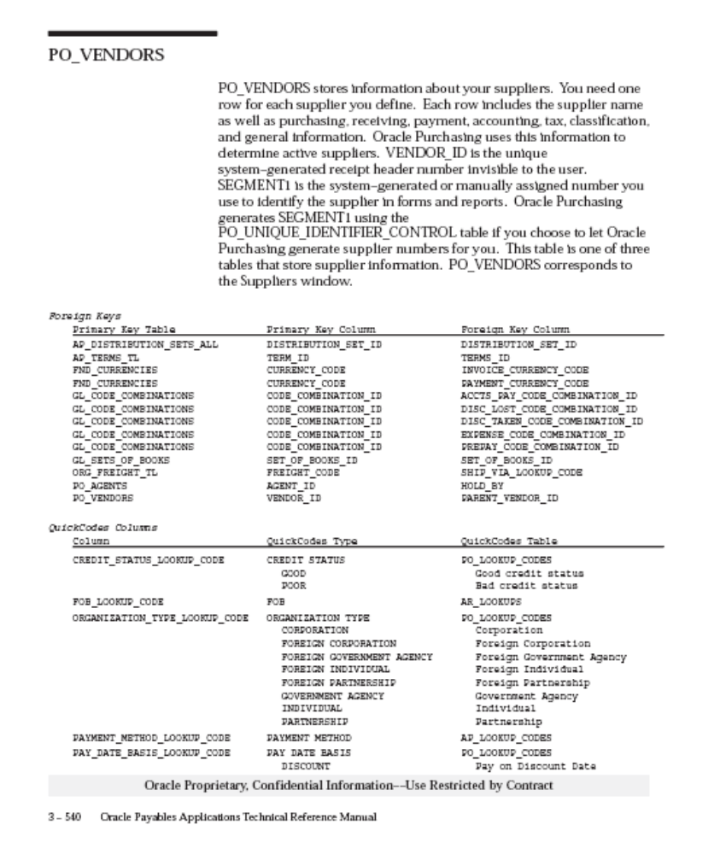
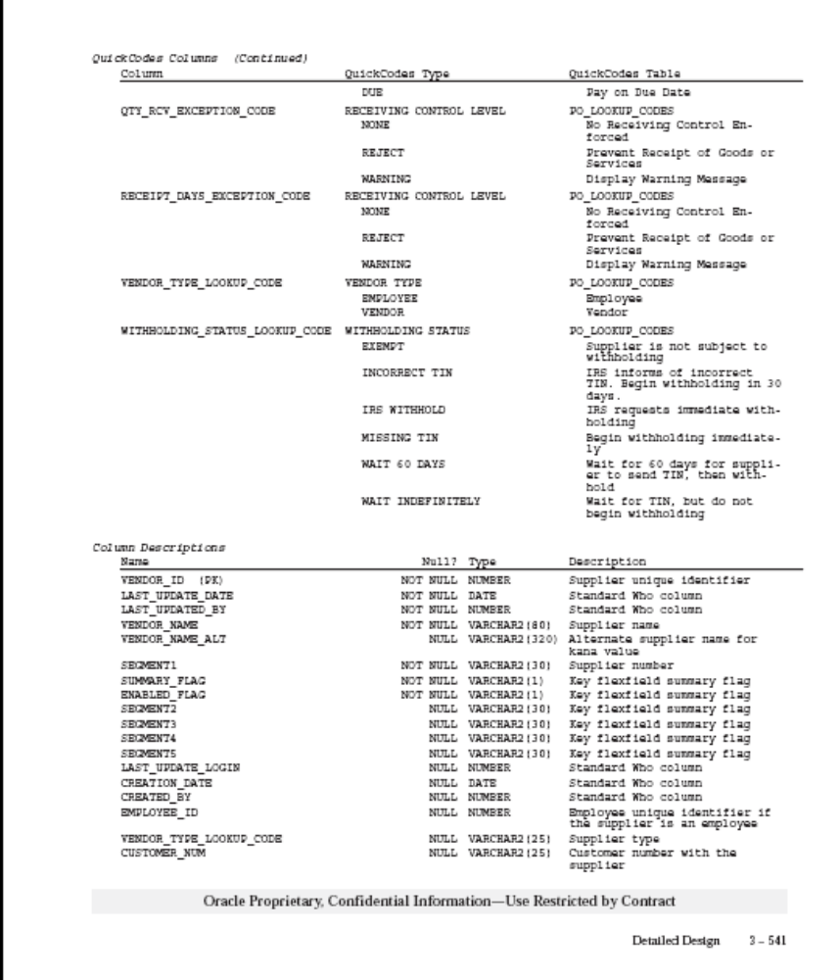
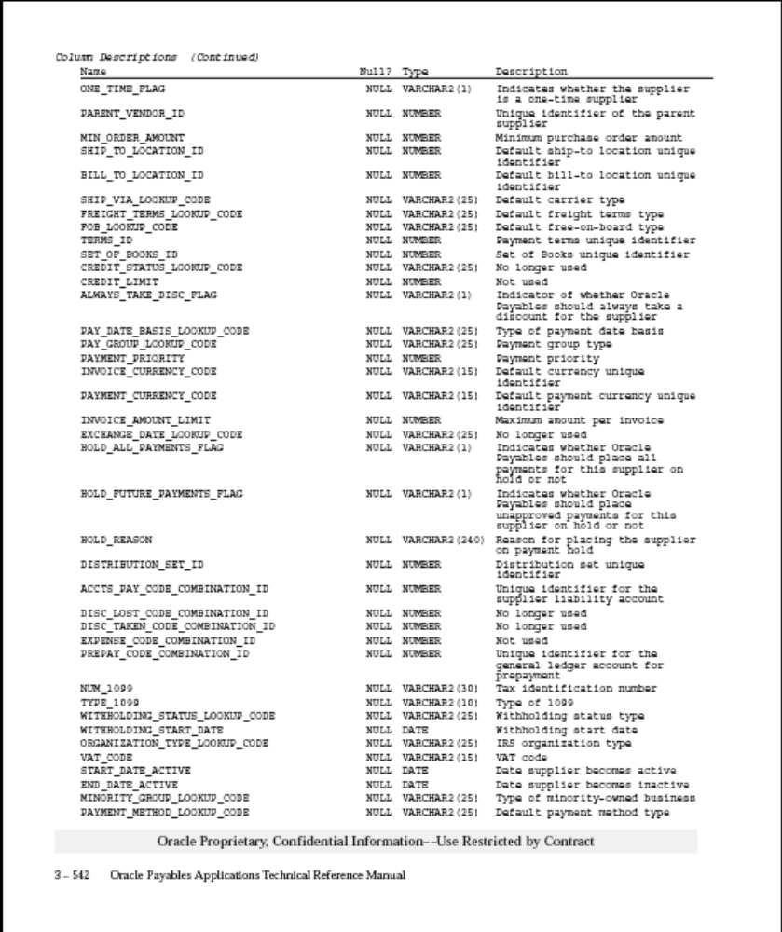

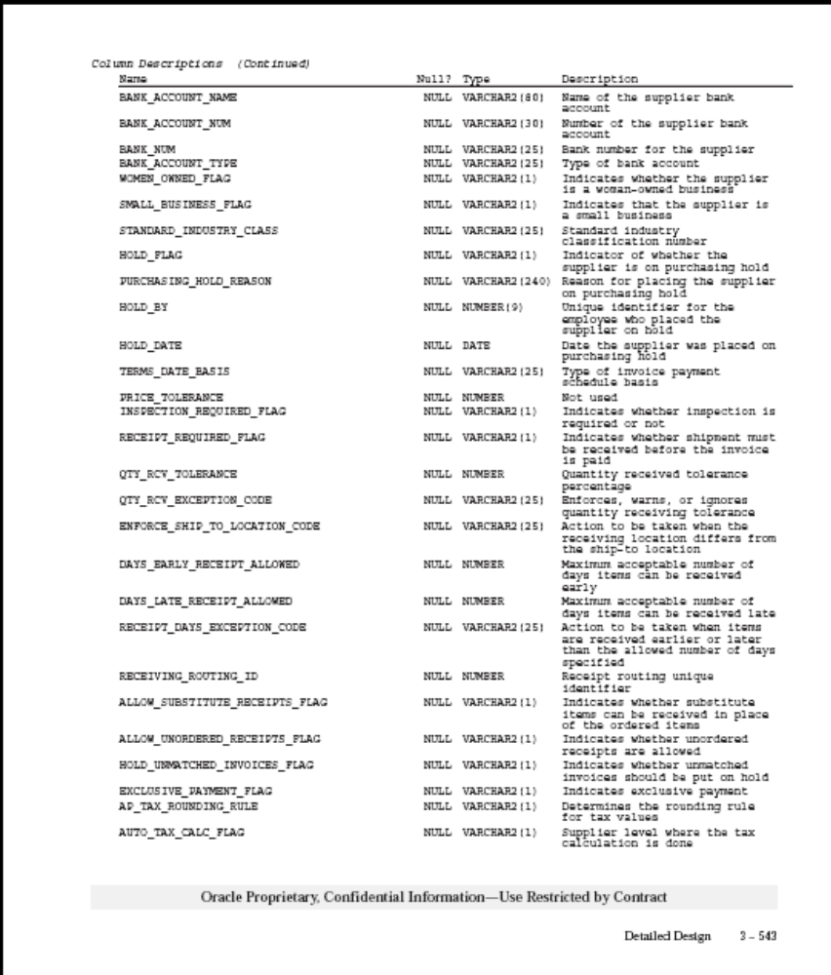

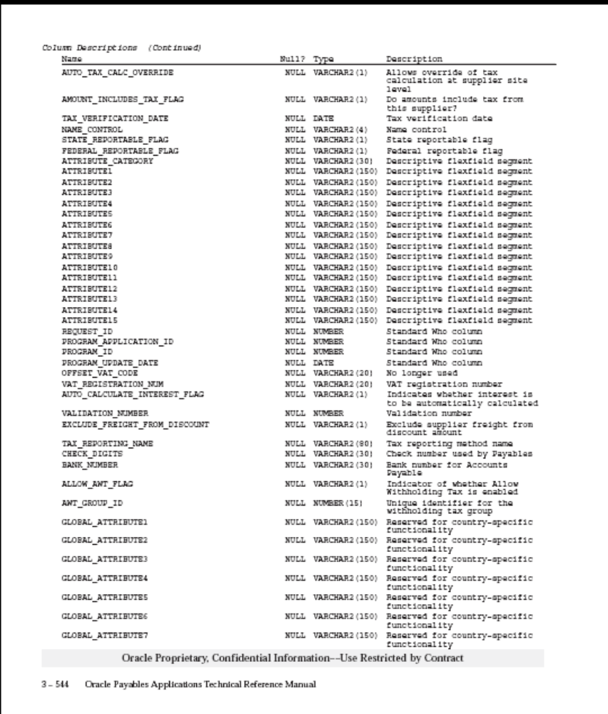
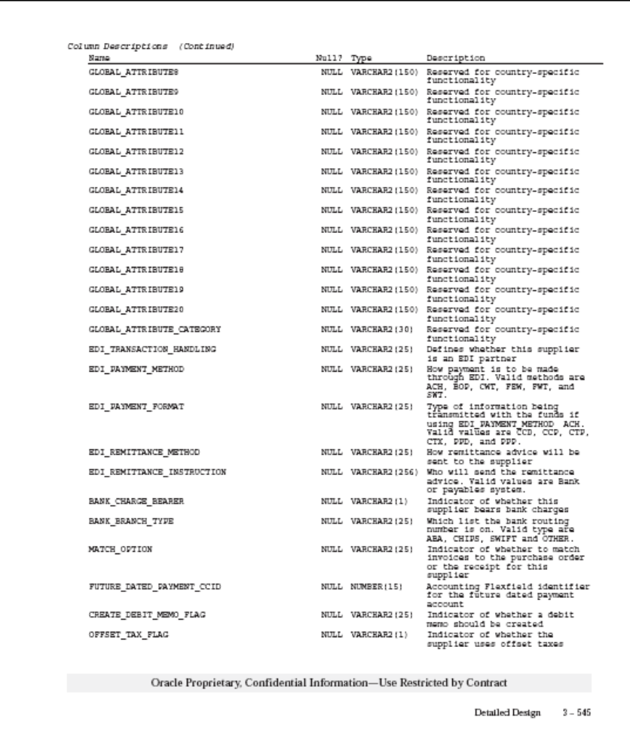
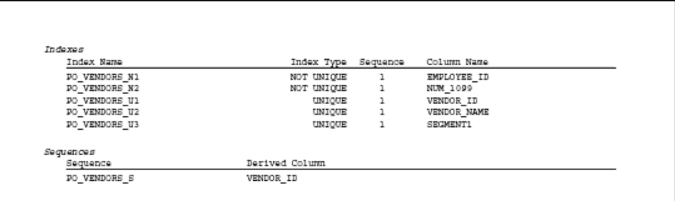

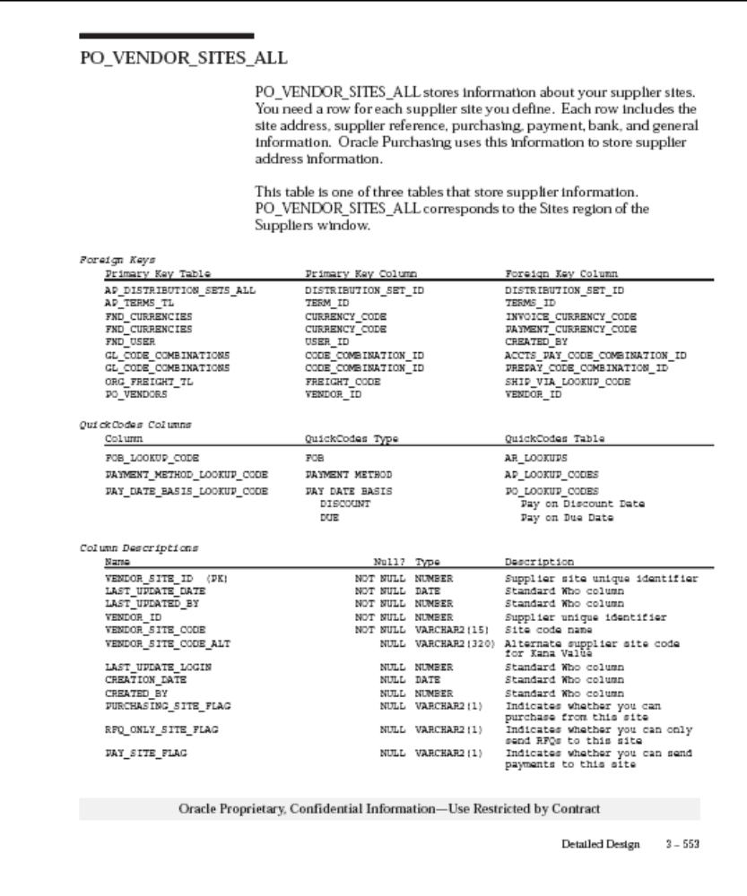
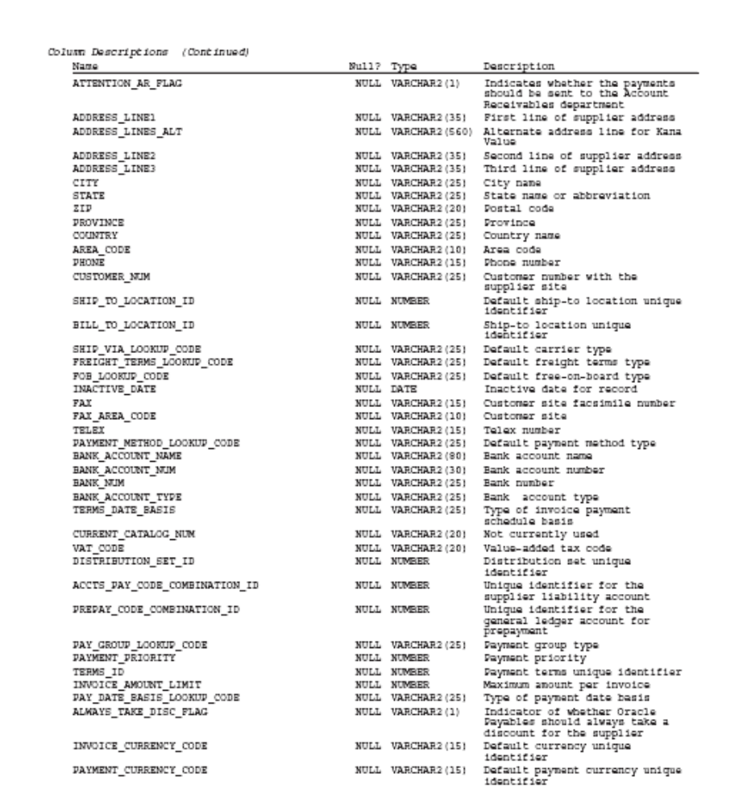

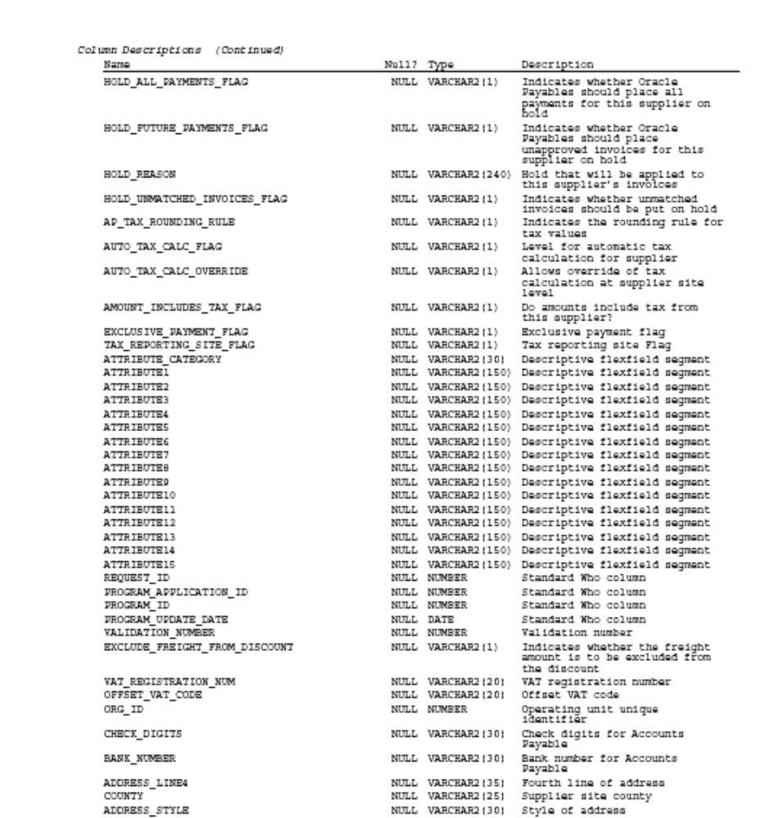

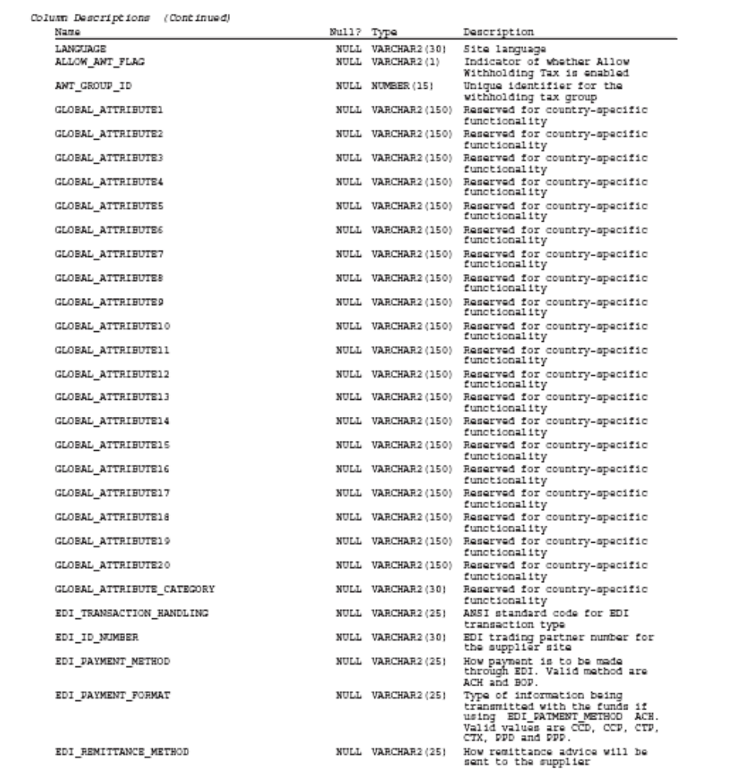

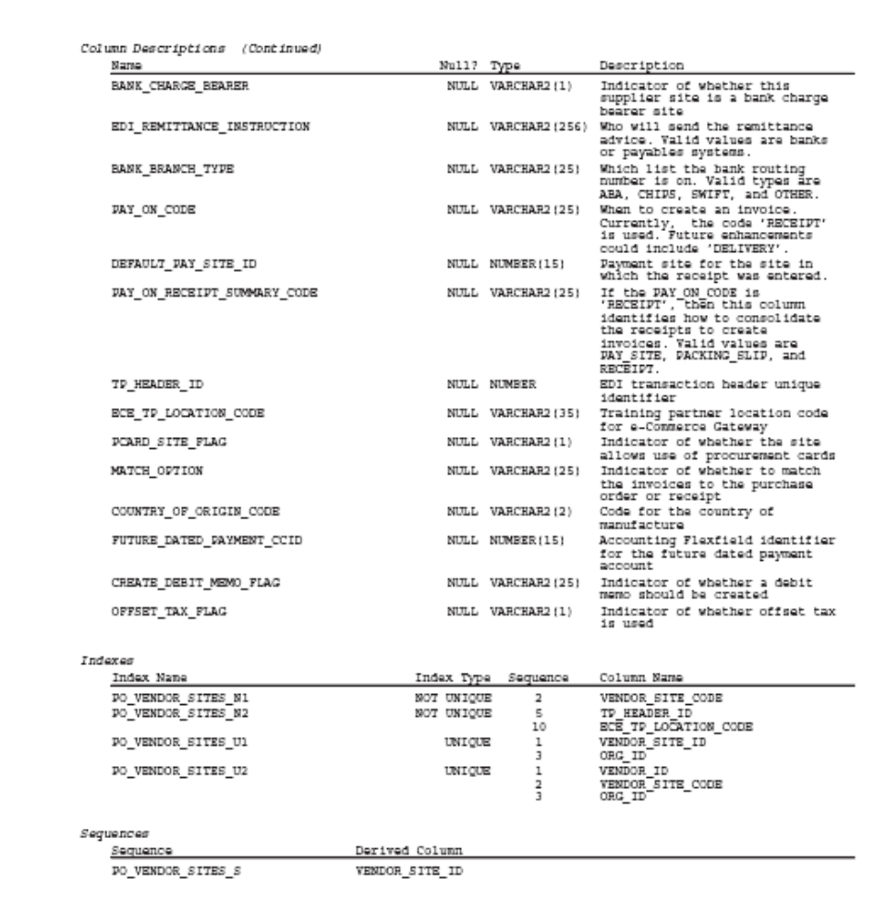
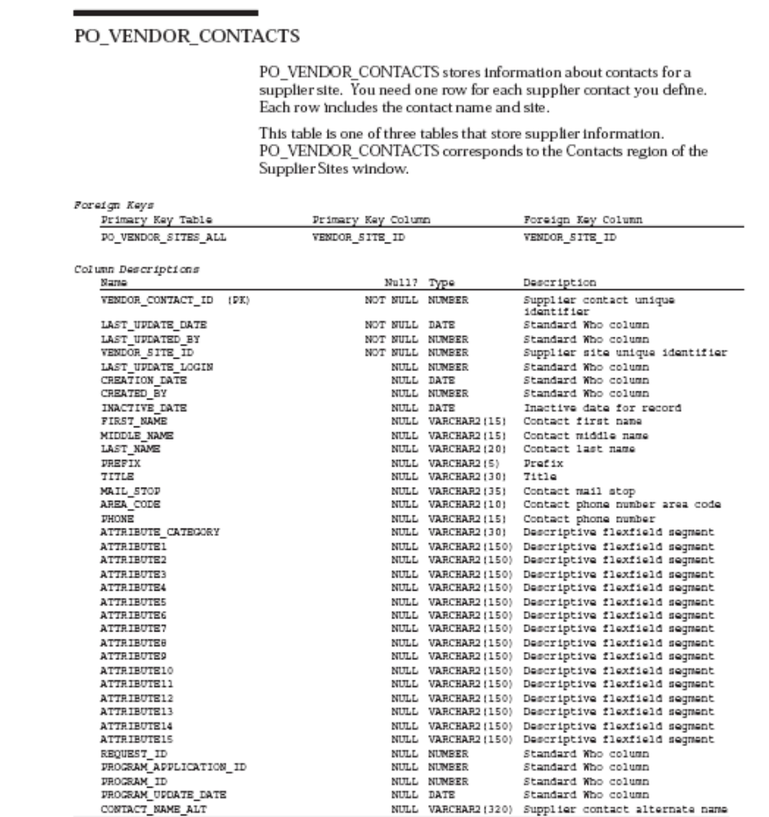

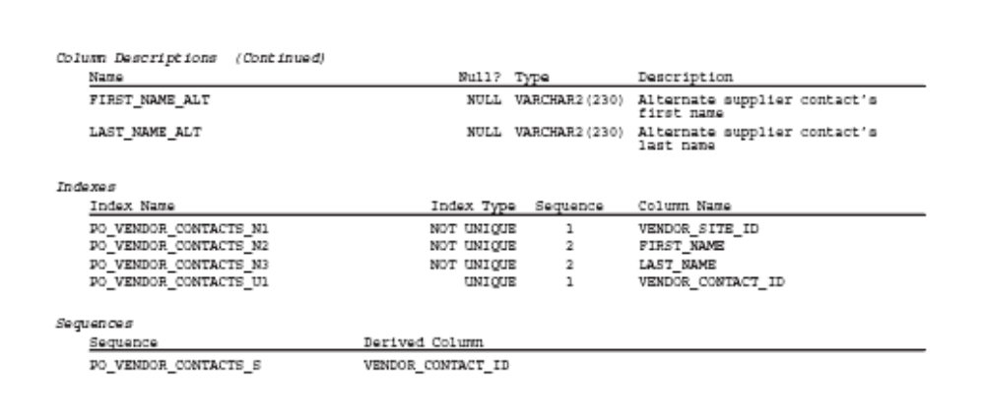

  - RIB RMS message format
See RIB Integration Guide 12011\XML_schemas for the latest formats. The schema for VendorHdrDesc and VendorAddrDesc is given below for convenience:-
(This will change for the 12T version)

Application Name: Retail Management System | Version 12.0.0 | XML-Schema or Node Name:VendorDesc.xsd

Tag Name | Table Name | Column Name | API Req | Description
VendorHdrDesc | * | * | Yes | Child node - see below.
VendorAddrDesc | * | * | Yes | Child node - see below.

Application Name: Retail Management System | Version 12.0.0 | XML-Schema or Node Name:VendorHdrDesc

Tag Name | Table Name | Column Name | API Req | Description
supplier | sups | supplier | Yes | Unique identifying number for a supplier.
sup_name | sups | sup_name | Yes | The supplier's trading name.
contact_name | sups | contact_name | No | The contact name for the supplier.
contact_phone | sups | contact_phone | No | Contact phone number for the supplier.
contact_fax | sups | contact_fax | No | Fax number for supplier.
contact_pager | sups | contact_pager | No | Pager number for supplier.
sup_status | sups | sup_status | No | A code to indicate supplier status. A = Active, I = Inactive.
qc_ind | sups | qc_ind | No | Determines whether orders from this supplier will default as requiring quality control.
qc_pct | sups | qc_pct | No | The percentage of items per receipt that will be marked for quality checking.
qc_freq | sups | qc_freq | No | The frequency for which items per receipt will be marked for quality checking.
vc_ind | sups | vc_ind | No | Determines whether orders from this supplier will default as requiring vendor control.
vc_pct | sups | vc_pct | No | The percentage of items per receipt that will be marked for vendor checking.
vc_freq | sups | vc_freq | No | The frequency for which items per receipt that will be marked for vendor checking.
currency_code | sups | currency_code | No | A code identifying the currency the supplier uses for business transactions.
lang | sups | lang | No | A code for the supplier's preferred language.
terms | sups | terms | No | A code indicating the payment terms that will default when an order is created for the supplier.
freight_terms | sups | freight_terms | No | A code indicating what freight terms will default when an order is created for the supplier.
ret_allow_ind | sups | ret_allow_ind | No | Indicates whether or not the supplier will accept returns.
ret_auth_req | sups | ret_auth_req | No | Indicates if returns must be accompanied by an authorization number when sent back to the vendor.
ret_min_dol_amt | sups | ret_min_dol_amt | No | Contains a value if the supplier requires a minimum value to be returned in order to accept the return. Stored in the supplier's currency.
ret_courier | sups | ret_courier | No | Contains the name of the courier that should be used for returns to the supplier.
handling_pct | sups | handling_pct | No | The percent to be multiplied by an order's total cost to determine the handling cost for the return.
edi_po_ind | sups | edi_po_ind | No | Indicates whether purchase orders will be sent to the supplier via Electronic Data Interchange.
edi_po_chg | sups | edi_po_chg | No | Indicates whether purchase order changes will be sent to the supplier via EDI.
edi_po_confirm | sups | edi_po_confirm | No | Indicates whether acknowledgements of purchase orders will be sent to the supplier via EDI.
edi_asn | sups | edi_asn | No | Indicates whether the supplier will send Advance Shipment Notifications electronically.
edi_sales_rpt_freq | sups | edi_sales_rpt_freq | No | This field contains the EDI sales report frequency for the supplier. Valid values are D = Daily, W = Weekly.
edi_supp_available_ind | sups | edi_supp_available_ind | No | Indicates whether the supplier will send availability via EDI.
edi_contract_ind | sups | edi_contract_ind | No | Indicates whether contracts will be sent to the supplier via EDI.
edi_invc_ind | sups | edi_invc_ind | No | Indicates whether invoices, debit memos and credit note requests will be sent to/from the supplier via EDI.
cost_chg_pct_var | sups | cost_chg_pct_var | No | Contains the cost change variance by percent. If an EDI cost change is accepted and falls within these boundaries, it will be approved when inserted into the cost change dialog.
cost_chg_amt_var | sups | cost_chg_amt_var | No | Contains the cost change variance by amount. If an EDI cost change is accepted and falls within these boundaries, it will be approved when inserted into the cost change dialog.
replen_approval_ind | sups | replen_approval_ind | No | Indicates whether contract orders for the supplier should be created in Approved status.
ship_method | sups | ship_method | No | The method used to ship the items on the purchase order from the country of origin to the country of import. Check the RMS data model for valid values.
payment_method | sups | payment_method | No | Indicates how the purchase order will be paid. Valid options are: LC (Letter of Credit), WT (Wire Transfer), OA (Open Account).
contact_telex | sups | contact_telex | No | The telex number for the supplier's contact.
contact_email | sups | contact_email | No | Contains an email address for the supplier's representative contact.
settlement_code | sups | settlement_code | No | Indicates which payment process method is used for the supplier. Check the RMS data model for valid values.
pre_mark_ind | sups | pre_mark_ind | No | Indicates whether or not the supplier has agreed to break an order into separate boxes (and mark them) that can be shipped directly to the stores.
auto_appr_invc_ind | sups | auto_appr_invc_ind | No | Indicates whether or not the supplier's invoice matches can be automatically approved for payment.
dbt_memo_code | sups | dbt_memo_code | No | Indicates when a debit memo will be sent to the supplier to resolve a discrepancy. Y = Yes, N = No, L = only if a credit note is not sent by the invoice due date.
freight_charge_ind | sups | freight_charge_ind | No | Indicates whether a supplier is allowed to charge freight costs to the client.
auto_appr_dbt_memo_ind | sups | auto_appr_dbt_memo_ind | No | Indicates whether debit memos sent to the supplier can be automatically approved on creation.
inv_mgmt_lvl | sups | inv_mgmt_lvl | No | Indicates whether supplier inventory management information can be set up at the supplier/deparment level or just at the supplier level.
backorder_ind | sups | backorder_ind | No | Indicates if backorders or partial shipments will be accepted.
vat_region | sups | vat_region | No | The VAT region for the supplier.
prepay_invc_ind | sups | prepay_invc_ind | No | Indicates whether or not all invoices for the supplier can be pre-paid invoices.
service_perf_req_ind | sups | service_perf_req_ind | No | Indicates if the supplier's services must be confirmed as performed before paying an invoice from that supplier.
invc_pay_loc | sups | invc_pay_loc | No | Indicates where invoices from this supplier are paid - at the store ('S') or centrally through corporate accounting ('C').
invc_receive_loc | sups | invc_receive_loc | No | Indicates where invoices from this supplier are received - at the store ('S') or centrally through corporate accounting ('C').
addinvc_gross_net | sups | addinvc_gross_net | No | Indicates if the supplier invoice lists items at gross cost ('G') or net cost ('N').
delivery_policy | sups | delivery_policy | No | Contains the delivery policy of the supplier. Valid values come from the DLVY code on code_head/code_detail.
comment_desc | sups | comment_desc | No | Any miscellaneous comments associated with the supplier.
default_item_lead_time | sups | default_item_lead_time | No | Holds the default lead time for the supplier. The lead time is the time the supplier needs between receiving an order and having the order ready to ship. This value will be defaulted to item/supplier relationships.
duns_number | sups | duns_number | No | The Dun and Bradstreet number of the supplier.
duns_loc | sups | duns_loc | No | The Dun and Bradstreet number of the location of the supplier.
bracket_costing_ind | sups | bracket_costing_ind | No | This field will determine if the supplier uses bracket costing pricing structures.
vmi_order_status | sups | vmi_order_status | No | Determines the status in which any inbound PO's from this supplier are created. A NULL value indicates that the supplier is not a VMI supplier.
end_date_active | * | * | No | Not used by RMS.
dsd_supplier_ind | sups | dsd_ind | No | Specifies whether or not DSD shipments can be created for the supplier.

Application Name: Retail Management System | Version 12.0.0 | XML-Schema or Node Name:VendorAddrDesc

Tag Name | Table Name | Column Name | API Req | Description
module | addr | module | Yes | Indicates the data type that the address is attached to. In this case, it will always be 'SUPP'.
key_value_1 | addr | key_value_1 | Yes | Holds the id the address is attached to. In this case, it will be the supplier number.
key_value_2 | * | * | No | Field not used.
seq_no | * | * | No | Field not used.
addr_type | addr | addr_type | Yes | The address type. Valid values (e.g. 01 - Business, 02 - Postal, etc.) are on the add_type table.
primary_addr_ind | * | * | No | Field not used.
add_1 | addr | add_1 | Yes | The first line of the address.
add_2 | addr | add_2 | No | Contains the second line of the address.
add_3 | addr | add_3 | No | Contains the third line of the address.
city | addr | city | Yes | Contains the name of the city associated with the address.
state | addr | state | No | Contains the state abbreviation for the address.
country_id | addr | country_id | Yes | Contains the country where the address exists.
post | addr | post | No | The zip code for the address.
contact_name | addr | contact_name | No | The name of the contact at this address.
contact_phone | addr | contact_phone | No | The phone number for this address.
contact_telex | addr | contact_telex | No | The telex number for this address.
contact_fax | addr | contact_fax | No | The fax number for this address.
contact_email | addr | contact_email | No | The email address for this address.
oracle_vendor_site_id | * | * | No | Field not used.
OracleOUDesc | * | * | No | Child node.

Application Name: Retail Management System | Version 12.0.0 | XML-Schema or Node Name:OracleOUDesc

Tag Name | Table Name | Column Name | API Req | Description
OUDtlDesc | * | * | No | Child node.

Application Name: Retail Management System | Version 12.0.0 | XML-Schema or Node Name:OUDtlDesc

Tag Name | Table Name | Column Name | API Req | Description
ou_id | org_unit_add_site | org_unit_id | Yes | The Oracle Financials org unit associated with this address.
site_id | org_unit_addr_site | oracle_vendor_site_id | Yes | The Oracle Financials site id associated with this address.

